# Double Trips to Venice

I have a goal as of late: to take the train into Venice weekly (if possible) until it's time to go home to Idaho. There is so much to see and learn, and I am finding out new details about my Bassano heritage all the time (relating to Venice). It's also quick and easy to get there from Vicenza, so that makes it all the more inviting to go as often as I can. In this post, I will share my experiences from two recent day trips to Venice, along with some updates about my family (including grandchildren). XOXO

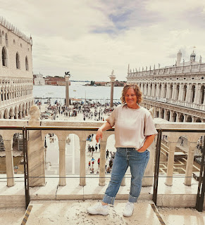

Happy Little Me, on the balcony of the Basilica next to the Doge Palace in St. Mark's Square

Trip #1 to Venice . . .

Below: The rough outline we made for the day when I went with my sister, Charmaine, and her husband, Scott. (September 12th) I spent some time mapping out the places we wanted to visit the most, placing them in order from who opened first, and then into as fluid of an order as I could, so we weren't criss-crossing all over the place. I made notes of how long it kind-of-sort-of takes on foot between locations so that we could gauge whether we wanted to hop on the ferry to get us there faster or not.

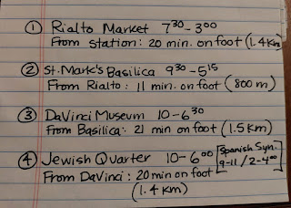

Our first stop in Venice was into a cute little cafe within the Santa Lucia train station so Charmaine could get a much-needed cup of coffee to start the day.

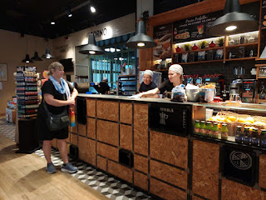

Then we made our way on foot to the Rialto Market. In the photo below, you can see the train station on the far right.

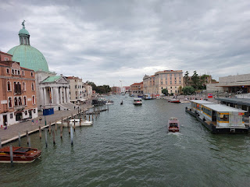

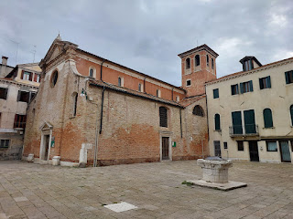

The Rialto Market is a historic and bustling market near the famous Rialto Bridge. It has been a central hub of commerce in Venice since the 11th century!! It functioned like a trading post for a long time, where merchants from around the world brought their goods, spices, and other wares to the city. Nowadays, this is where the local Venetians shop for daily supplies.

You can find fruits and vegetables, including these vibrant peppers . . .

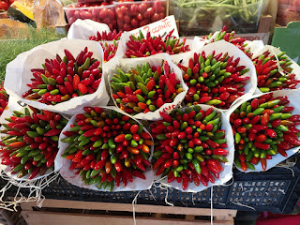

Several fish of all kinds . . .

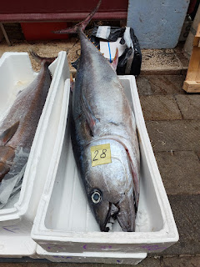

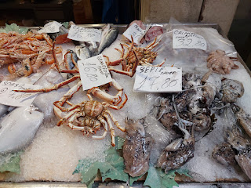

There are several varieties of pastas, grains, and gift ideas, too. Charmaine had fun filling up her basket with pastas and risottos for her coworkers back in San Diego.

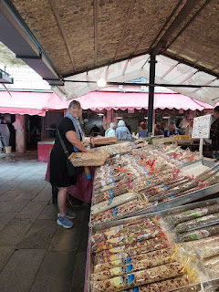

Close to the Rialto Market, there is a Traghetto stop. This is a unique gondola experience where you can pay 2 euros per person and the gondoliers will paddle you across to the other side of the wide canal. It's a great opportunity to have the experience itself and to get a few photos in.

Video as we were ferried across in the gondola: (8 seconds)

https://photos.app.goo.gl/tdVzn8A8vfkAQY5QA

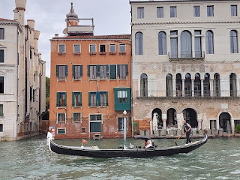

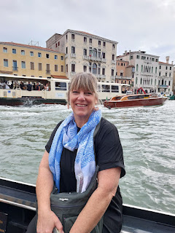

A few minutes later, we hopped onto the ferry, a larger taxi-boat service in Venice.

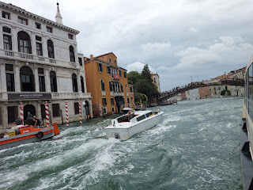

I didn't realize it until we got close to the Accademia Bridge, but we ended up passing right by the old Bassano House! I was excited to see it from the middle of the Grand Canal this time, since it took us a bit to find it on foot back in June. In the photo above, you can see the wooden bridge that is known as the Accademia. The Bassano House is just beyond the bridge on the left hand side, if you're heading toward St. Mark's Square.

Video #1 as we approached the Bassano House: (57 seconds)

https://photos.app.goo.gl/dxZaHEyef82qwbpJ7

Video #2 as we approached the Bassano House: (23 seconds)

https://photos.app.goo.gl/Zg8DF4AXBBgcQh6X8

The Bassano House can be seen in the photo below: of the two bright coral-colored buildings, ours is the one on the right.

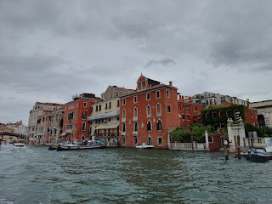

We continued on for a few more minutes, enjoying the sights from the ferry, and not having to walk for a bit was especially nice.

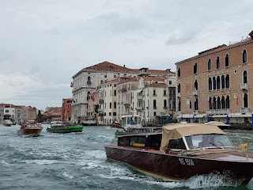

We got off at a stop that I had not used before, known as the San Marco Vallaresso "A" stop. This allowed us to walk past the Royal Gardens of Venice, so we decided to go in briefly to have a look around.

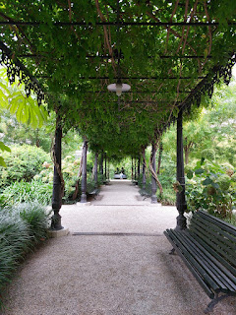

It was free to enter the Royal Gardens, which was nice.

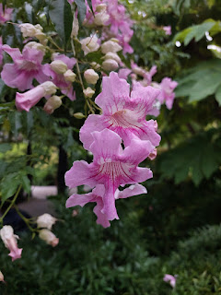

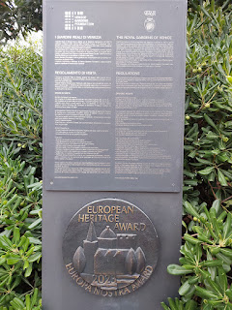

Click on the photo below to learn more about the Gardens, which originated in 1807 through the efforts of Napoleon.

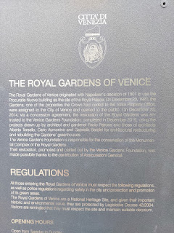

In the fall months, Venice can often suffer from high water levels that fill up St. Mark's Square. The phenomenon is known as "Acqua Alta", or high water. It occurs most often between October and March, but especially in November and December. Some of the causes are attributed to:

The water levels in the Venetian Lagoon, due to high tides, storms, and strong winds.

Climate change: Venice is sinking by about 2 mm per year because of melting glaciers, which causes worldwide sea levels to rise. The average sea level of Venice has risen almost a foot since 1900.

Groundwater Pumping: Venice also sank nearly 5 inches between 1950 and 1970 due to the pumping of groundwater. Although this has since stopped, Venice still sinks 2 mm per year.

As we made our way toward the Doge Palace and Basilica, we had to navigate between several shallow puddles and a few much deeper puddles.

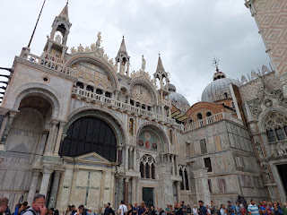

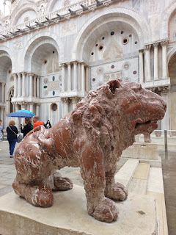

We decided to get lunch first before getting in line for the Basilica, choosing a nearby pizzeria where we could sit outside and watch the swarms of tourists walking by . . .

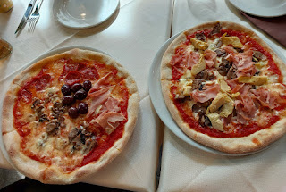

On other visits, the Piazza is usually busy with people and families. But not this time. The water was a few inches deep, so most people steered clear of the large square.

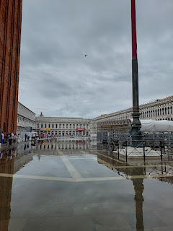

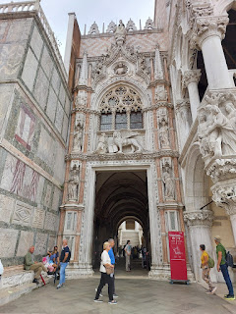

As we stood in line for the Basilica after lunch, I noticed that water was bubbling UP from the drains in the ground!

Video of the water next to where we stood: (7 seconds)

https://photos.app.goo.gl/wW4kLvDp5AwjyzHz6

It only costs 3 euros to get into the Basilica (as of this writing), but the added "cost" comes with the time you spend standing in line just to get inside. (usually 30-45 minutes) Still, it's definitely worth it. This was my second time visiting the Basilica, having gone last September with my friends, Scott & Jenn Anderson, from Idaho Falls.

The vaulted ceiling above the ticket booth . . .

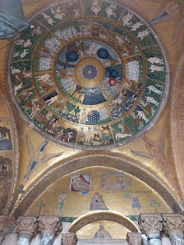

There is an abundance of gold mosaic tiles everywhere, giving the interior a feeling of majesty along with commanding some respect for the painstaking love and patience that went into creating these deeply religious scenes.

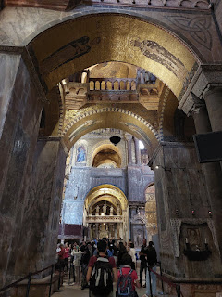

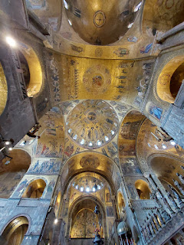

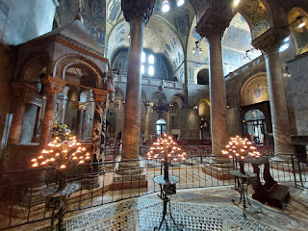

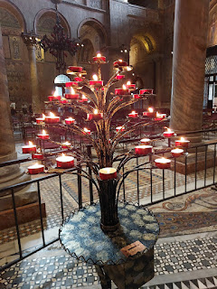

If you choose to continue the tour upstairs (and you definitely should), you'll pay an additional 7 euros per person once you reach the top of the stairs.

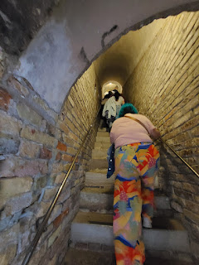

It is mind-boggling to see all the millions of tiny gold tiles up close, as you try to comprehend how someone made all of them into so many massive and exquisite pieces of ART . . .

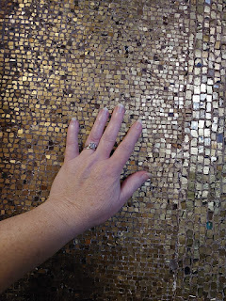

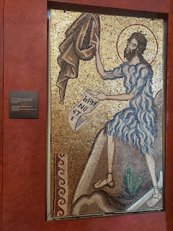

This was only my second time visiting the Basilica, but the #1 thing I looked forward to seeing again was this . . .

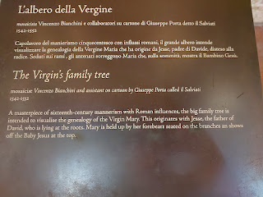

Thousands of tiny little gold tiles are what make up this expansive and awe-inspiring family tree . . .

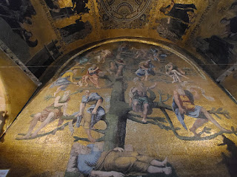

I love how the description of Mary's family tree mentions how her forebears held her up. This is also true for each of us now. Our loved ones that are in heaven are also working hard in our behalf. They are watching over us, they encourage us, they sometimes lend protection to us, they care about us, and they want to help us. What a beautiful concept - but even more, what a beautiful truth!

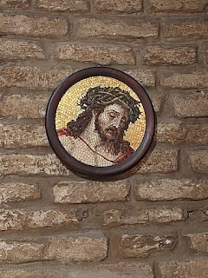

I tried not to take too many photos this time, since I know I took sevvvveral last year when I went the first time.

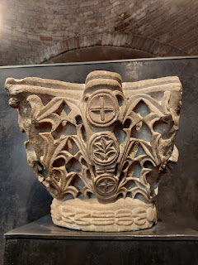

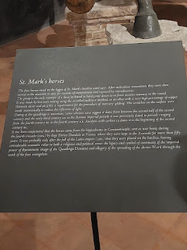

St. Mark's Horses: dated back to the first part of the 2nd century AD.

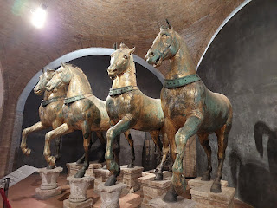

Looking over the upper balcony, and seeing the expanse of the grand chapel below . . .

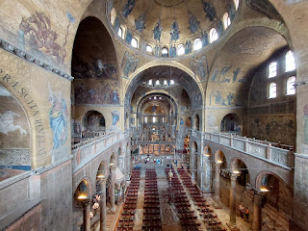

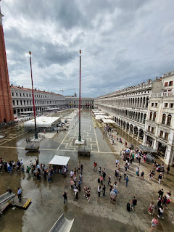

Looking down into St. Mark's Square - seeing the flooding below . . .

Video of the flooded square: (16 seconds)

https://photos.app.goo.gl/q7hK8m2BXjWvachB6

If you can't beat 'em, join 'em . . . as Bugs Bunny would say.

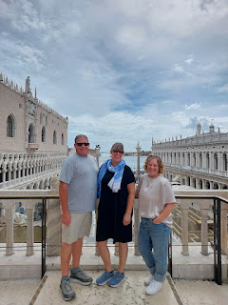

Above: Scott, Charmaine, and Me

Below: A description of the the spiritual symbolism found inside the Basilica and the purpose of the gold mosaic tiles. Click the photo to enlarge and read - sorry if it's a tiny bit difficult to decipher in parts.

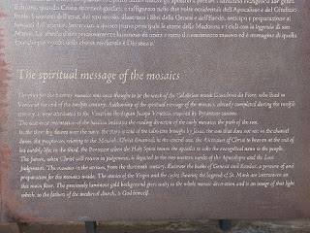

Video as we began sloshing our way back through the square to return to the ferry boat: (5 seconds)

https://photos.app.goo.gl/i4nb5Y38iJAqpGcY6

There was the skinniest of skinny pathways for 3 lanes of pedestrian traffic down in the flooded square, and it was difficult to navigate. The shallowest section consisted of regular 2-way foot traffic through the square, plus a line of people who were waiting to get into the Basilica. We all wanted to stake our claim to the 10-inch wide path with the least amount of water depth, ha ha. Charmaine wanted to take off her socks and shoes and just slosh through it all, which would have made our journey a lot faster. But (her) Scott and I weren't "feeling it", so we just slowly worked our way through instead. A sloth might have made it through faster than we did . . . but we finally got through the worst of it and made our way back to the ferry stop near the Royal Gardens.

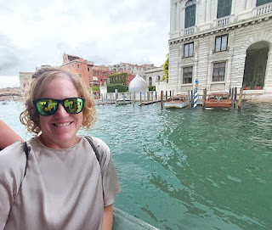

Passing the old Bassano House one more time . . . XOXO

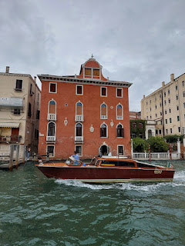

We got off the ferry at the San Toma stop, and made our way on foot from there to the DaVinci Interactive Museum of Venice. Charmaine oohed and aahed over the storefront displays of Venetian masks, wishing that she could share these things in person with her daughters.

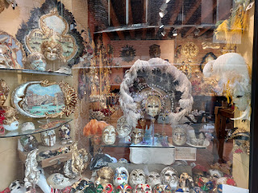

I had already been to the DaVinci Museum last fall with Amber and her family, so I opted to do a little exploring on my own next door while Charmaine and (her) Scott visited the museum.

The Grand School of San Rocco was right across the "street" from the DaVinci Museum, and there was a Church of San Rocco right next door as well. I began my tour there first.

Video of a street performer outside the church entrance, playing a song with several glasses filled with water: (54 seconds)

https://photos.app.goo.gl/L4MSb3rtwbeueMxk6

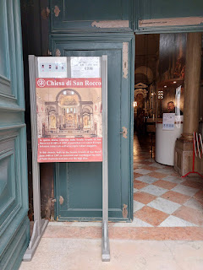

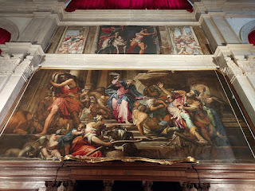

I had to pay 3 euros to get in, but it was very quiet and I was surprised to see that there was only one other person in the church besides me.

This was a thought-provoking scene . . . Mary and an empty chair. Maybe the empty chair is symbolic of the empty tomb?

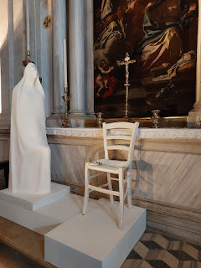

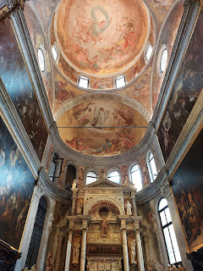

I am ALWAYS noting the chunky cross symbol that is connected to the Knights of the Templar and my Bassano ancestors . . . I keep seeing it in so many places in Northern Italy . . .

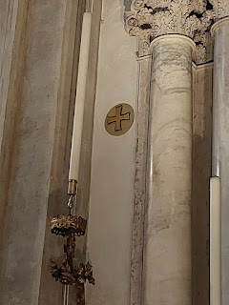

San Rocco . . . something about it was pulling at me, but I couldn't quite put my finger on why . . .

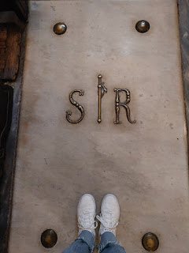

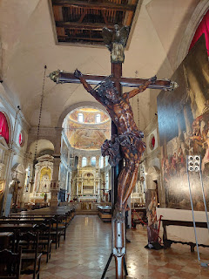

I didn't spend too long in the church, because I wanted to have some time to spend in the Scuola Grande di San Rocco before Charmaine and Scott were done at the Museum. I paid something like 8 or 10 euros to enter the School.

This was the ground floor . . . I didn't understand at first what the layout of the building was, or what all I would even be seeing. I had done a total of ZERO research prior to my entering, lol.

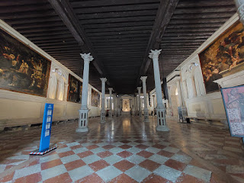

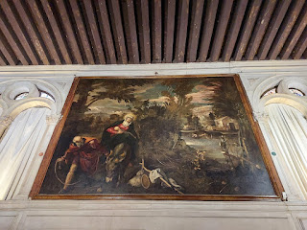

At first, I was just thinking, wow, this is some beautiful art down here. But then I noticed the staircase leading up to something more . . .

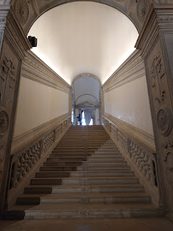

On the next landing, there was light and peace and goodness that emanated throughout . . .

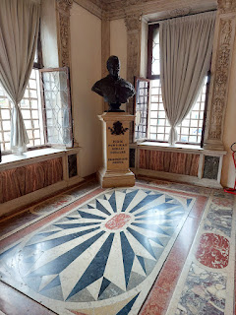

A translated sign near one of the windows, spoke of the terrible plague that haunted Venice in 1576, killing hundreds. Click photo below to enlarge and read.

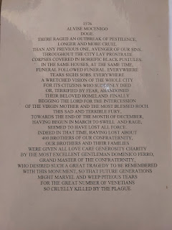

And then I saw ANOTHER staircase leading upward, this one was quite grand and beautiful . . .

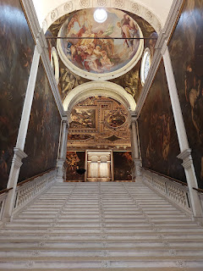

THIS is what was in that uppermost "room": (22 seconds)

https://photos.app.goo.gl/FYp59ekGFugB1HMG6

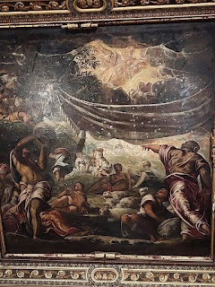

Several of the masterpieces that adorn the walls and ceiling of the Scuola Grande di San Rocco were made by the artist Jacopo Tintoretto. He attended this school and became quite famous during his lifetime.

A side "conference room" of sorts . . .

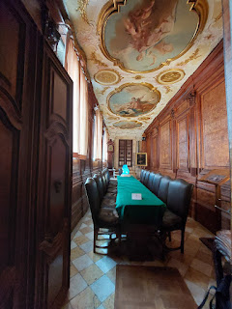

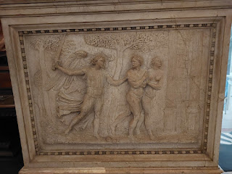

There was also a room with some extensive restoration work going on for a Tintoretto painting . . .

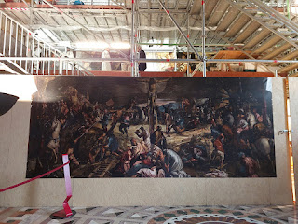

I sat down to watch a video showing how the restoration work is being conducted: (1 min 28 seconds)

https://photos.app.goo.gl/rzuQvXXoUAcdWfqr5

I took a video of the video, so it's not a complete explanation, but I took the video with my artist daughter, Amber, in mind.

In summary, the impromptu visit to the Grande Scuola di San Rocco was absolutely worth my time. It ended up being a super special experience. When I went up that second grand staircase, I remember thinking, "I wonder if  . . . (my Bassano ancestors ever came here or worked here)?" No sooner did the thought begin to unfold in my mind, then I received the most joyous and energetic response, "Yes! We were here! We were here! And we are here now, too . . ."

Just imagine my shock at such an emphatic and immediate response! Firstly, they knew my thoughts! And secondly, they were there with me. Wow. No longer did I consider myself "alone" as I continued on that tour. It brought tears to my eyes as I contemplated those reassurances and communications from the spirit world. We are not alone in this realm of existence. And each time I seek to connect to my ancestors by visiting someplace that was significant to them long ago, I am never disappointed.

It does require being quiet and still, though. If I am with someone who is talking "too much", I might ask them to be quiet for a moment so that we can have the potential to feel something, or to hear something in our hearts. I often enjoy going to places like this on my own for that very reason. I want to be able to be in tune with whatever thoughts, feelings, or impressions might come, and not be distracted by whatever present conversation we might be having.

I am so very grateful for the sacred interactions that I have had with my Bassano family in Venice. This is what made me want to make the effort to go back every week, or as often as possible, until I leave Italy for good. I want to make more connections, find more places of significance, and then document them all.

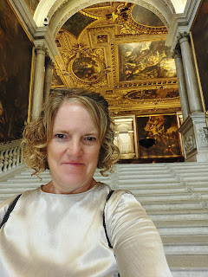

I bought a few books in the bookstore of San Rocco before meeting up with Charmaine and Scott again outside. I was pretty emotional as I tried to share what I had felt inside the school just a few minutes before.

We had one more stop to make before we finished up in Venice: the Jewish Quarter. After getting lost a few times trying to find the San Toma ferry stop, we eventually had success and got on the ferry. The rain was starting to fall while we rode up the canal, and it rained the rest of the time we were there.

A sign on one of the buildings, pointing us to a synagogue . . .

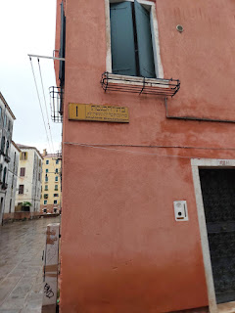

It was humbling and special to share this square in the Jewish Ghetto with my sister. In a corner of the square, there are several plaques that hang on the walls paying homage to the Jewish family members who were hauled off during WWII from this very place. Out of 289 individuals who were deported and sent off to Auschwitz, only 7 returned home alive.

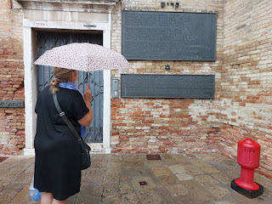

For some, it is customary to leave a small stone as a way of saying, "I came. I was here."

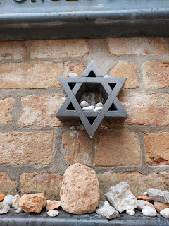

I think that the building next door, that used to be where Eduardo Bassano lived before he was deported, is now some sort of hotel or hostel. I saw several people coming and going through the open door, many of which were clearly tourists. Note the "tripping stones" on the ground in front of the doors. These are plaques to honor the individuals who used to live there, but who were hauled off to concentration camps and killed during WWII. A German artist has created thousands of these plaques, as a way to make amends for the atrocities that previous generations have committed.

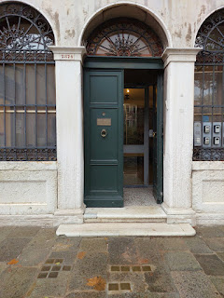

We had intended to tour a synagogue together that day, but with the rain and our tired feet, we were too exhausted when we learned that the tour would be another 45 minutes . . . so we found a cute shop in the Jewish Quarter to investigate instead.

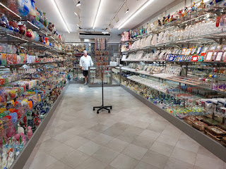

I ended up buying 2 necklaces made from Murano glass, both for a great price. (less than $20 a piece)

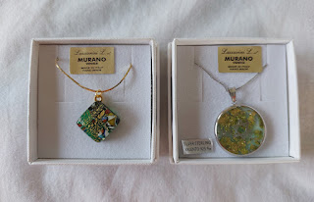

We hauled our little goodies back to the train station and went home. 'Twas a very good day. I'm glad I was able to visit Venice with my sister and to share one of my favorite places in the world with her.

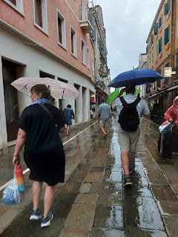

The "in betweens" . . .

In between Round One of company and Round Two, I cleaned the house, tried some new recipes, and prepared some boxes for shipping. I wanted to send my mother something special from Italy for her 75th birthday, and I was so excited to see my friend Michele (pronounced "mee-KELL-eh" in Italian) with his olive wood wares set up inside the PX on base. I decided on a beautiful cutting board with the phrase "Buon Appetito" on it. Due to its length, it required a little bit of finesse to fit it into a box to send to my mom, but I made it work, ha ha.

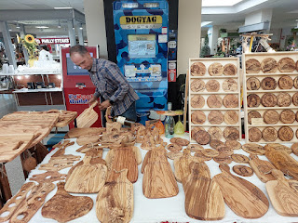

When I saw this recipe on Instagram recently, I knew I needed to try it. Here are a couple of screenshots with the instructions below. (click photos to enlarge)

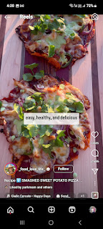

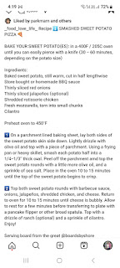

Ours turned out pretty great, and goodness gracious they were tasty!!

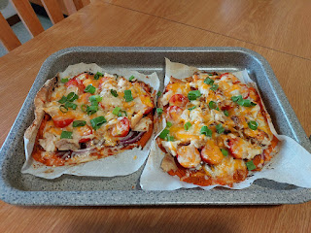

While preparing a package to send to my daughter, Amber, I was curious about one of the books that I had received for free in the Civic Museum of Bassano del Grappa. It's a children's guide to the story and art processes of Jacopo dal Ponte, also known as Bassano, whose art is on display inside the museum. I started using Google Translate to see what the story was all about, and oh my goodness, I realized right away what a treasure it is!! It has some wonderful family history about him and his family, and HALLELUJAH - I finally found the connection between Jacopo dal Ponte and the BASSANOS!! See if you can spot it, too. (

Clue:

a detail on the 2nd page coincides with another clue on the 8th page)

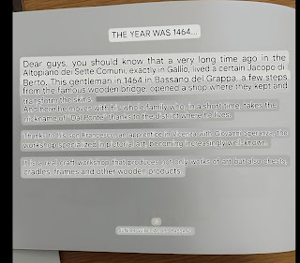

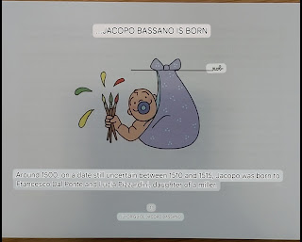

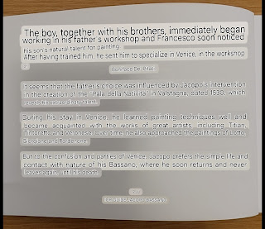

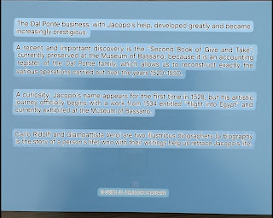

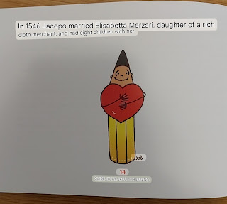

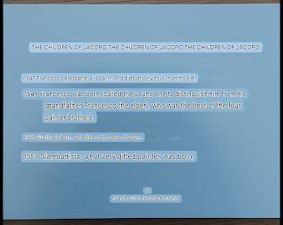

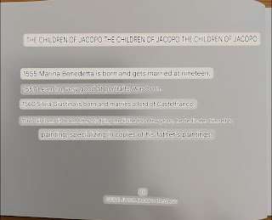

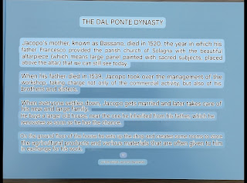

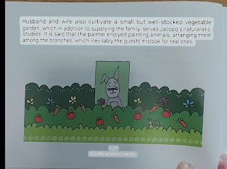

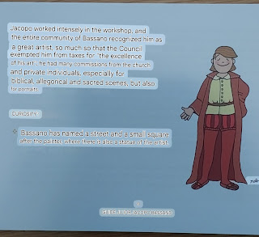

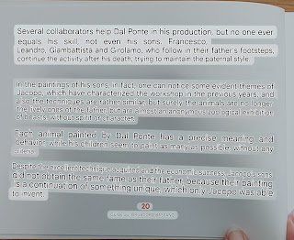

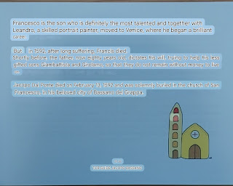

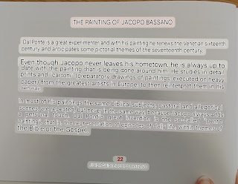

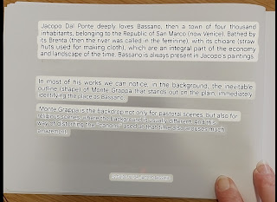

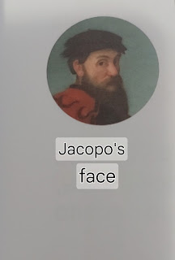

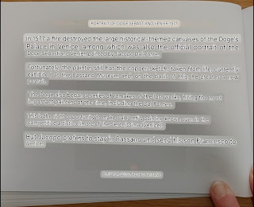

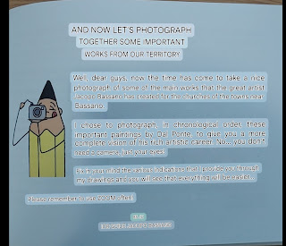

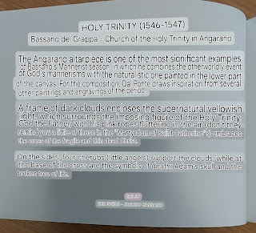

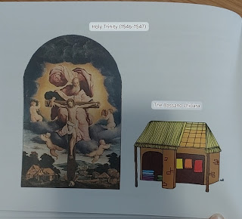

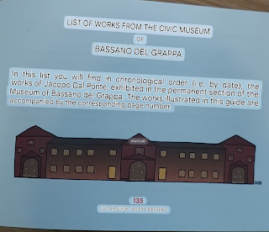

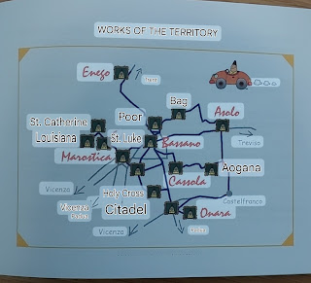

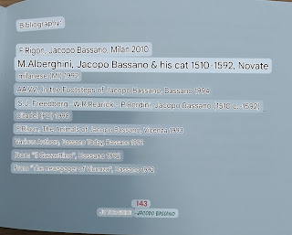

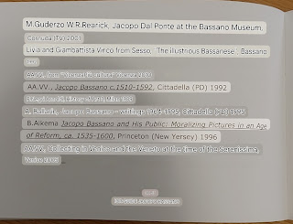

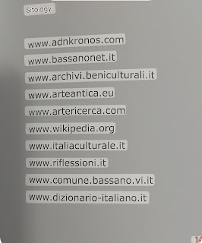

While the tidbits in this children's guide don't tell us EXACTLY which Bassanos are directly connected to Jacopo dal Ponte, it is clear (and important) that the ITALIANS consider them to be related. I did a little bit of perusing on FamilySearch and Ancestry.com and saw that someone had linked these two articles as record sources for Jacopo. (see below)

https://en.wikipedia.org/wiki/Jacopo_Bassano

https://www-ilgiornaledivicenza-it.translate.goog/argomenti/cultura/cultura/i-bassano-la-pittura-affare-di-famiglia-1.438681?_x_tr_sl=it&_x_tr_tl=en&_x_tr_hl=en&_x_tr_pto=sc

It will definitely require more thorough research to see what else can be discovered, but alas, I will need more time . . . and when I eventually DO find something, I will be sure to report back.

I shipped off a whopping SEVEN packages that day. Holy cannoli . . .

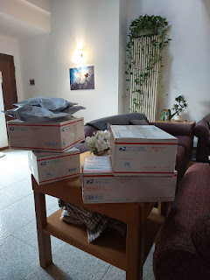

Another new dinner that was a big success for the two of us was this one: sauteed shrimp, sauteed cabbage and carrots, some spicy and flavorful sauces from the Commissary, and some lettuce wraps to nestle and bundle the ingredients together. So fast and so easy and so tasty!!

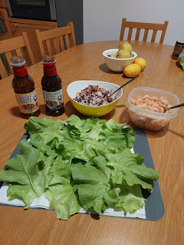

On another day, I accompanied my friend, Kelly Campbell, up to Nove, a little town known for its ceramics. I've been wanting to choose a pattern of dishes that I can send home with all of our household goods at the end of our service in Italy. I am happy to report that I found one! I love the pattern on this set, but it was also important for them to have a decent upward edge so that gravy doesn't end up oozing off the sides, ha ha. Some of the other dish sets didn't have a good edge to hold the gravy in . . .

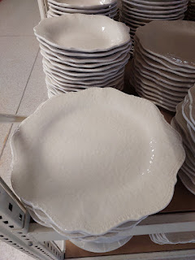

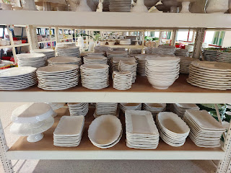

At a second store, we got to see how some serving platters are made: (47 seconds)

https://photos.app.goo.gl/xXjYdHWi7GM27Fe1A

A beautiful sunrise in Vicenza one morning . . .

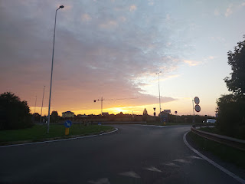

We also drove up to Aviano to visit our darling little granddaughter, Avery, who will be 3 years old in November. We met Kylie and Avery at a taco bar, where we had a short lunch together and then we drove over to their house - a short distance away.

Video of Avery's excitement as she recognized us: (4 seconds)

https://photos.app.goo.gl/cEbWwDzVvb3EmJav8

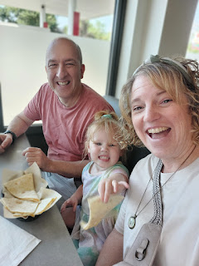

Video of Avery flinging a soft soccer ball and giggling while I rode in the back seat with her to their house: (9 seconds)

https://photos.app.goo.gl/57f3nEH1qW1cEK4y9

Avery was in love with the little stuffed doggy I brought for her . . . XOXO

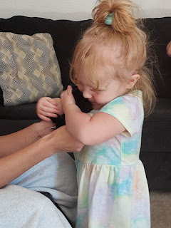

We went on a walk from their house, around the corner, past the church, and into the countryside where we could launch the drone. It was warmer than we would have liked, but we found a shady spot to watch from . . .

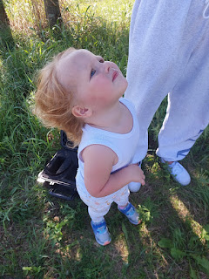

Avery is so silly - and so expressive with everything. She has many words she can say and that are easily understood. Kylie has also taught her sign language, which I noticed Avery using often. I love that there is a good option for these sweet little ones to be able to communicate what they're feeling and/or wanting, and I love that Kylie took the time to teach these things to her daughter.

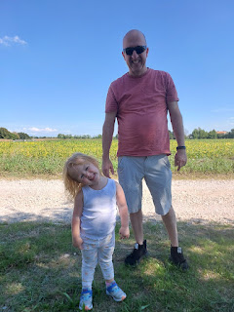

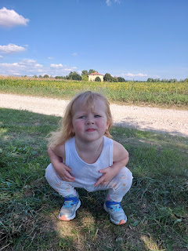

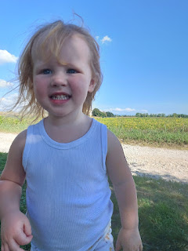

Kylie also taught Avery how to do the "duck lips" pose and hold up your fingers with the "peace" sign. Avery's version was SO CUTE and so hilarious at the same time - can you see her trying to hold out her two fingers to say, "peace"? She's using her pointer finger and her pinkie, LOL. What a cutie!!

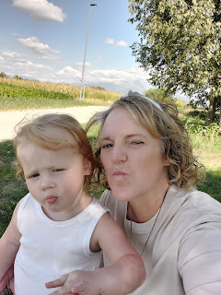

Kylie and Avery . . .

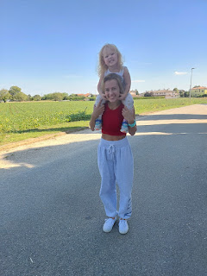

Avery wanted to stop inside the cemetery on our way back to their house. Much to her disappointment, however, we didn't stay very long. It was pretty toasty out in the sun, and because Avery wanted to be carried the whole way, we were all getting tired as we took turns carrying her. She's not as light as a feather anymore, ha ha.

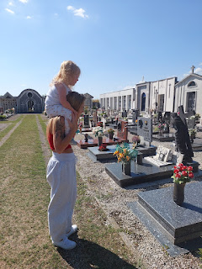

We ended up spending about 3 hours with them and it was just lovely. Nothing felt rushed or awkward. It was relaxed and comfortable and wonderful. On a side note, I just found out that Kylie got married last weekend! Her boyfriend, Miles, who is also in the Air Force, just came back from a 5 or 6 week deployment. I know that Kylie has been hoping for this for a long time, and I think they are very happy together.

When I asked Benson how he felt about this, since he is the one who told me, his response was, "I am genuinely happy for her." What a stand-up guy he is. :)

Digression: When I was typing up my blog recently, Scott came in and pointed out the creepy shadow on the wall behind me . . .

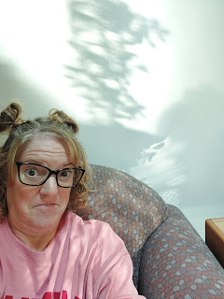

Scott's oldest sister, Carol, and her husband, Mike, have been called to serve as senior missionaries down in San Diego!! They leave in the next few days to head down, but they thoughtfully set up a Zoom link so those of us that are far away could still listen to them speak in Sacrament meeting a couple Sundays ago. They did an amazing job and I am so grateful for their willingness to serve the Lord wherever He wants to send them. San Diego ain't a bad gig, though . . . just sayin'.

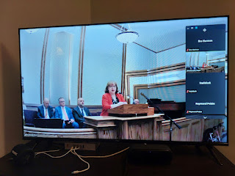

Their daughter, Kim, and her family sang a beautiful musical number together . . .

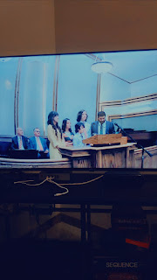

.

Mike always has a story and a twinkle in his eye to go with it . . .

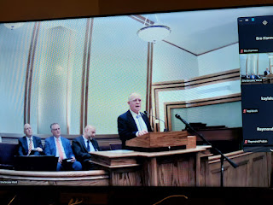

Amber and her family are getting settled in pretty well up in Portland. Amber has had some health issues, though, but she is working diligently on them while under the care of a doctor and a nutritionist. She's been extremely low in iron, Vitamin D, several hormones, and a few other symptoms. Bless her heart. I bet she still smiles all day, every day though. Because that's Amber. :)

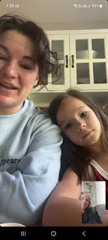

Amber, Abby, Weston, and Gwen . . .

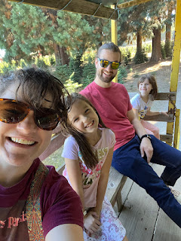

Maisie continues to delight everyone with her cuteness . . . XOXO

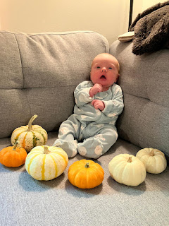



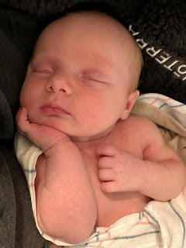

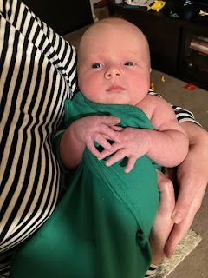

Just a couple more "in betweens" and then I'll get back to sharing my other day trip to Venice.

I had a favor to perform for our friends back in Idaho Falls (the Blatters) who have been taking care of a few tasks for us (installing new light fixtures next to the garage door & cutting up the wood from the tree that was taken down in August). When I asked Stephen if there was something I could send him from Italy, he suggested that I could find a bracelet for his daughter, Mercedes, who will be graduating in the spring. You betcha!

I had no idea where to start, but I started with Shop #1 in downtown Vicenza (a town who - incidentally, is known not just for the architect Andrea Palladio, but also for its jewelry making!). Their prices were quite high (in the 1700-2900 euros range) and they didn't have any silver offerings, but they very kindly sent me over to a colleague of theirs who has a lot of jewelry made from silver.

I walked over (less than 5 minutes away) and this is where I totally hit the jackpot.

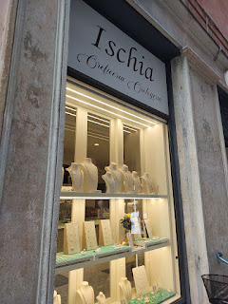

The jeweler himself dug out several trays and rolled up bundles of bracelets galore for me to ogle. I took several photos, with his permission, and waited to hear back from Stephen.

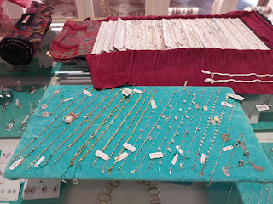

I am happy to report that many of these bracelets at this particular shop are in the range of 22-44 euros each. MUCH more reasonable!! I ended up picking out a couple of bracelets with some help from Stephen, and then I selected a couple of simple - yet elegant - bracelets for myself. I don't consider myself to be much of a jewelry person, but when you live in a place that's known for their jewelry, AND their prices are very affordable, AND you're about to leave this place forever, you just gotta.

The jewelry shop is literally this close to the main Piazza in Vicenza, and you can see the green copper roof of the Palladian Basilica, as well.

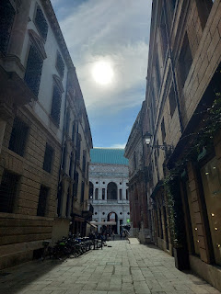

If anyone wants me to pick out something for you, I would be HAPPY to do it. Our friends that recently visited us (the Garners) came to the shop with me, and Andrea chose a beautiful necklace to take home. Locally owned, locally made = refer everyone I can to them. :)

Another dinner success we tried recently was this soup: Cozy Autumn Wild Rice Soup

Link to the recipe:

https://www.gimmesomeoven.com/cozy-autumn-wild-rice-soup/

If I could only make ONE SOUP the whole winter long, it would be this one.

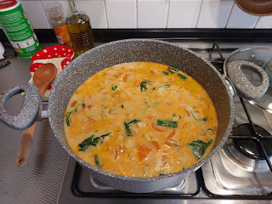

Trip #2 to Venice . . .

My friend, Kelly Campbell, was hoping to join me on this day trip (September 26), but was unable to, so I went to Venice by myself. I wasn't too sad about this, because I do love to explore by myself, which allows me to pay better attention to any impressions and feelings that I might have.

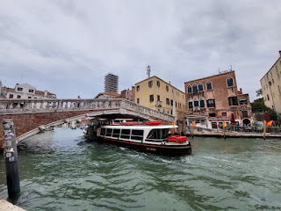

After I got off the train at the Santa Lucia Station, I turned left (north) to walk directly to the Jewish Quarter again. The big square is called "Campo del Ghetto Nuovo" in the shape of a tall pilgrim's hat. (only sort of, ha ha, but seriously, look on Google Maps), and is surrounded by several tall buildings. Many of these buildings are where the Jews were forced to live for many years, overcrowded - yet forced to be confined to this small space where the only way to expand was to go "up".

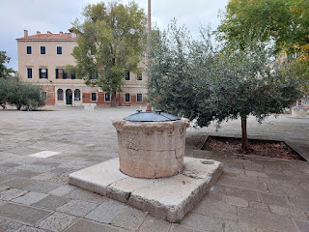

Most "neighborhoods" in Venice had just one cistern/well as part of a system for collecting rainwater, but the Jewish Ghetto had three. Why? Because there were roughly 700 people that lived in this very small ghetto and they required more than the average amount of water to survive. Families would collect rainwater into the cisterns using rain gutters, and this was supposed to be enough to support everyone, even through the very hot summers.

There were two large gates to keep everyone locked in the Ghetto at night. The only ones who could freely go in and out were doctors and a few bankers. The medical professionals didn't have to wear the yellow cap that distinguished them from Venetian Christians, nor did they have to wear the typical yellow badge to identify them as a Jew.

Jewish families were required to pay the guards who kept them locked in at night. Can you even imagine?

There are two bridges that connect this tiny "island" to the nearby neighborhoods of Venice. I arrived early in the morning on a Thursday, so I had some time to kill before the synagogue tours began at 10:00 a.m. I paused on the north bridge as I left the Ghetto to take it all in.

Looking to my right (east) . . .

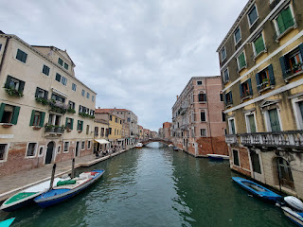

Looking to my left (west) . . .

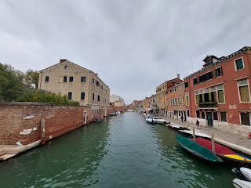

I headed toward a couple of places that I had pinned ahead of time on Google Maps. I decided to head for the furthest one to the east, the Monastero di Santa Maria della Misericordia.

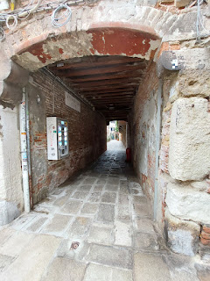

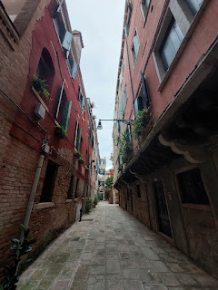

Below: The driver of a boat in the middle of the canal drove past me with the song, "Who Can It Be Now" cranked up at full volume, LOL. (By the 80's group, Men at Work)

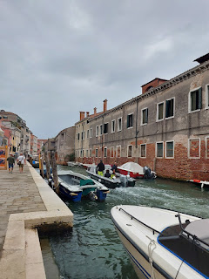

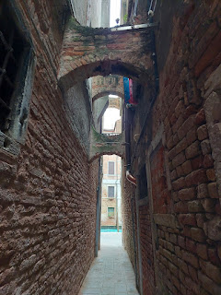

Finally, I could see the building in front of me, just beyond the covered walkway . . .

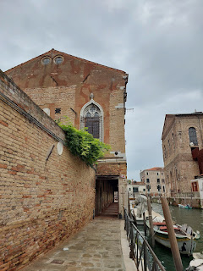

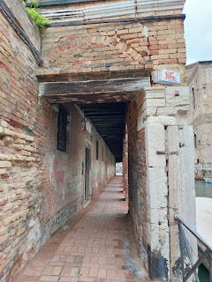

The bricks in the covered walkway were a very rich color, next to the deep green of the canal . . .

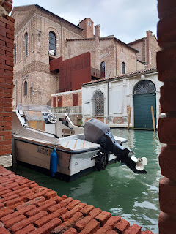

The front door of the old monastery . . .

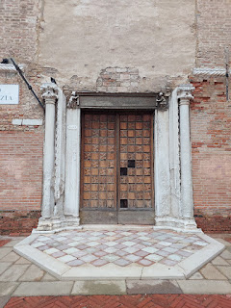

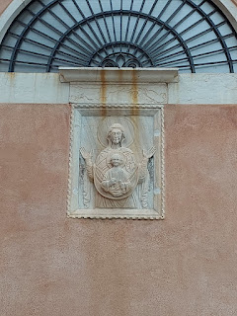

In my studies on the Bassano Family, I learned that my 17th great grandfather, Jeronimo Bassano, attended and worked here. The note that I attached to my saved "pin" for this landmark on Google Maps records the following:

Jeronimo de Bassan was the leading pifaro player at this school. It was a school, or brotherhood, and a secret Venetian confraternity, of which the Bassanos were members. Jeronimo led sacred musical processions through the streets of Venice to honor the dead with illuminated candles.

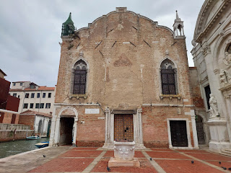

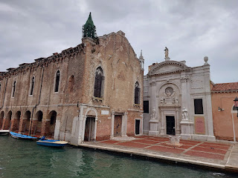

The building that I wanted to go into looked very much abandoned from the outside. The lighter-colored building adjacent to it had a sign out front designating an art exhibition, but it, too, wasn't open for the day yet.

I didn't want to hurry on to the next place on my list, because this spot was so peaceful. So I found a place to sit on the edge of the canal across from the Monastery.

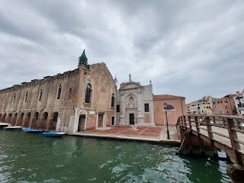

Video of the peaceful scene before me: (19 seconds)

https://photos.app.goo.gl/ZDHCN7Fq9QDkBbCa7

I didn't know this until I started prepping for this blog post (a couple weeks later), but the place that I visited was SUPER CLOSE to the

right place

, but it wasn't actually the

right place

.

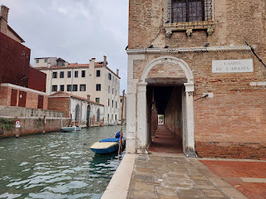

Apparently, there are FOUR distinct and different places that I was easily mixed up by, and they are all in very close proximity to each other.

1.

Monastero di Santa Maria della Misericordia:

This was a religious convent and dates back to the 13th century. This is the building that appeared to be abandoned from the outside and this was the one I actually visited.

2.

Palazzo da Lezze alla Misericordia:

"Palazzo" means "palace". This was a noble family's residence and was built in the early 17th century. It is just across the canal from the Monastery (#1 above) and is situated to the south.

3.

Scuola Vecchia della Misericordia:

"Vecchia" means "old", so this refers to the Old School of the Misericordia. This was the original building used by the Confraternity of the Misericordia, a lay religious brotherhood dedicated to charity and community service in Venice. It was located in a smaller structure before they eventually needed to move into something larger. THIS smaller one is the building that I need to go back and visit, because - on further investigation - as I dug through my historical book about the Bassano Family, this is where my 17th great grandfather, Jeronimo Bassano, worked and conducted various community projects (including leading an annual parade with candles and music through the streets of Venice). *Note: sometimes when you type something into Google Maps, the app may alter the name you typed in, to coincide with the current name that is presently identifiable. In my case, I had to use ChatGPT to distinguish all of these confusing similarities and to get the ACTUAL and ORIGINAL address. Now I have it pinned correctly on Google Maps for my next visit. The address is: Fondamente de la Misericordia, 3539, Venezia.

4.

Scuola Grande della Misericordia:

This is the newer and larger version of #3 above. The Confraternity finally moved into this location in 1583 after several decades of work and various efforts to get it all ready.

SHEESH. I wish I had known all of this before, but it's alright. I don't mind wandering the streets of Venice - EVER. I was soooo close to the right place, and I had good feelings while I was in that neighborhood. I don't consider my efforts to be a failure in the least. It was just part of my learning process, and now I am eager to go back again in a week or so for further exploration.

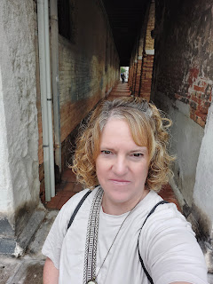

It was still very early in the day (around 9:00 a.m.) and many places still weren't open yet. So I continued my wanderings to see what I could see, as I made my way back toward the Ghetto where I could tour the synagogues once they opened up.

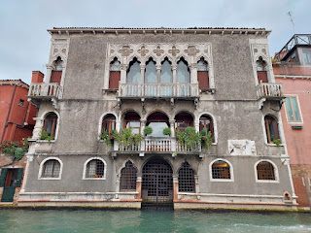

I found a beautiful church to enter . . .

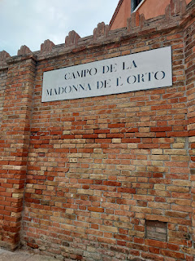

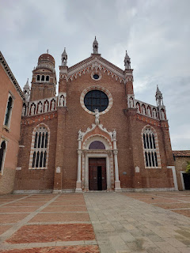

The Chiesa (Church) della Madonna dell'Orto was originally built in the mid-14th century by the Humiliati, a religious order dedicated to manual labor and humility. It was initially dedicated to St. Christopher, the protector of travelers and sailors. But the name of the church was changed later, due to  a statue of the Virgin Mary that was created by a local sculptor, Giovanni de Santi. The statue was believed to have miraculous powers!

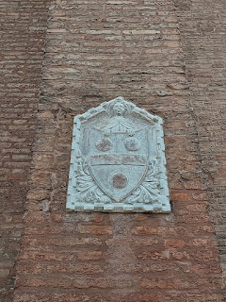

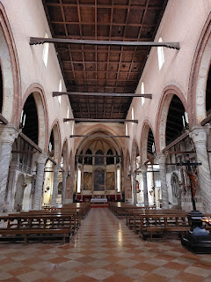

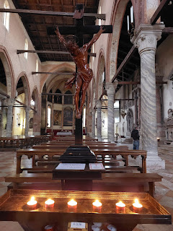

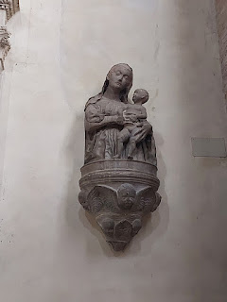

Something else that makes this church extra special is that it houses several works of art by the local artist, Jacopo Tintoretto (1518-1594). He not only lived in this neighborhood, but he (along with other members of his family) is also buried in this very church.

This is the famed (and miraculous) statue of the Madonna, the reason for the church's name . . .

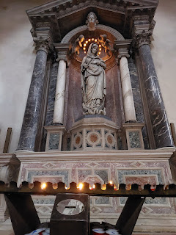

The inscription on Tintoretto's tombstone: (click photo to enlarge)

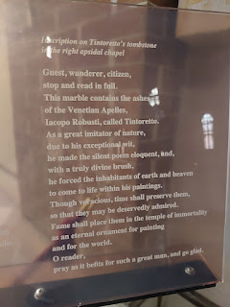

The tomb where his body was laid to rest . . .

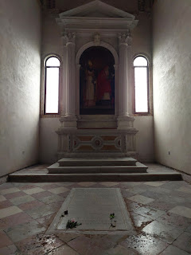

A small sculpture bust of Tintoretto . . .

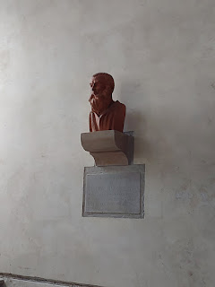

The plaque below reads: (with translation) The church is a place of prayer: During the Liturgies, visits are not permitted. Tintoretto Chapel - Tomb of Jacopo Robusti, known as Tintoretto (1519-1594), his daughter Marietta (1560-1590), and his son Domenico (1560? - 1635).  And at the very bottom it says "No Foto". (oops . . .)

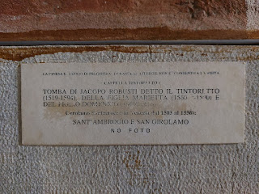

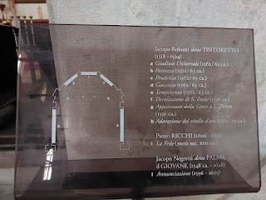

Above: a list of some of the works of Tintoretto that surround the altar, seen in the photo below.

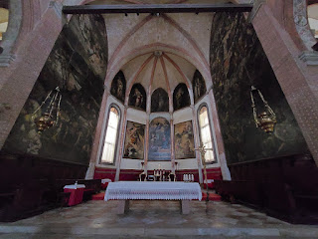

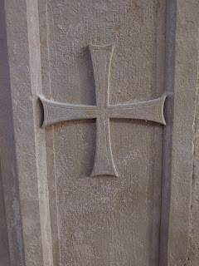

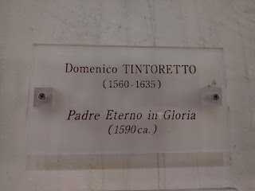

A beautiful painting by Tintoretto, named "Eternal Father in Glory", circa 1590.

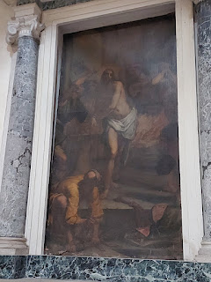

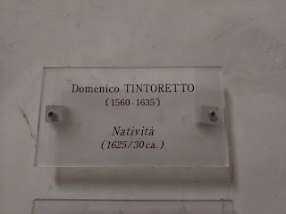

Another Tintoretto, but this one is by the son Domenico, entitled "Nativity".

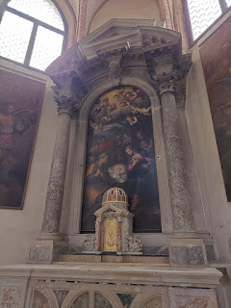

After leaving the beautiful church, I saw on Google Maps that just around the block sits the old house where Tintoretto used to live. Of course I'm gonna go over and take a look!

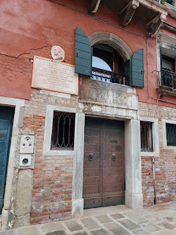

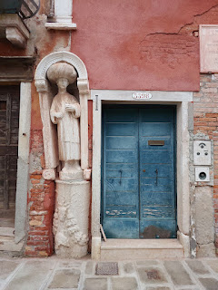

The cutest little doorbell buzzer that says, "Ca Tintoretto" (Tintoretto House).

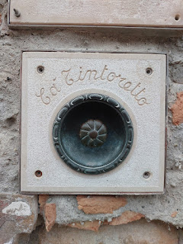

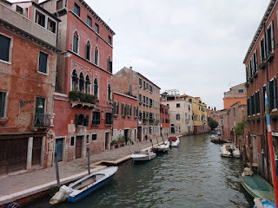

Now it was finally time to head back to the Ghetto and prepare for a tour of the synagogues.

As I crossed the bridge, where one of the gates to keep the Jewish people in used to be, I stopped to watch some "worker guys". If you have ever wondered how they get building supplies from place to place when everything is surrounded by WATER, here is your answer.

Video of the worker guys: (24 seconds)

https://photos.app.goo.gl/JMFuJ12PcddarZPg6

Something I hadn't noticed before, on the outside of the restaurant where Scott and I ate back in June, is a large Memorial Wall, dedicated to the Jews of the Venetian Ghetto.

The plaque reads (with translation): The Jewish Community of Venice to its Deportees. Sculpture Project. The Last Train. 1943 - 1993.

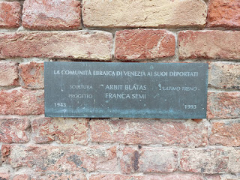

The sculpture shows how the Jews were crammed together and forced onto that "Last Train", as they rode off to their impending death . . .

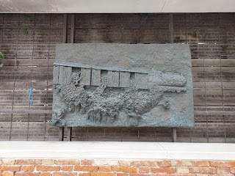

The inscriptions on the wooden panels behind the sculpture include each person's name who was taken from their home, along with their age. Some, I see, were as young as 7 or 9 years old. Others were as old as 81 or 83 years old.

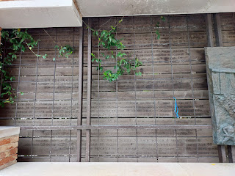

Inside the ticket office for the synagogue tour, I had to wait a few minutes for the tour to fully assemble. So I read some of the signs around the office and took photos of a few.

This one shows a portion of the Book of Psalms as it had been translated into Yiddish in 1545, the first of its kind in Italy.

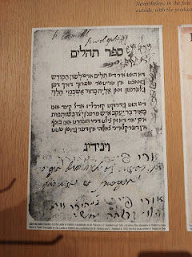

Next: An explanation of how the Jewish Cemetery on Lido Island came to be, and how it needed to be protected from desecration. (Click the photo to enlarge - it's in English) Note: There are Bassanos buried in this Cemetery and I intend to visit this sacred place on one of my weekly visits this fall.

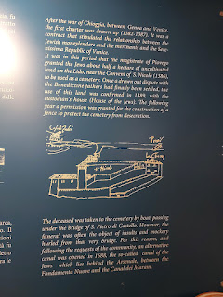

I was particularly interested in this next bit of information in the ticket office, because it talks about the influence of the Levantine Jews who came from the Iberian Peninsula (Spain) and how they strove to nestle into Venice, among the other Jews with slightly different customs. My Bassano ancestors also came from Spain and settled into Bassano del Grappa and Venice, before many of them moved to London later on.

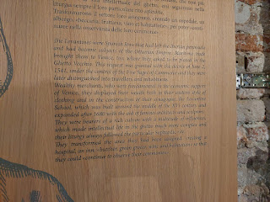

An extension of the timeline of the Spanish Jews, along with a description of some of the difficulties they faced. (Click photo to read the bottom half in English)

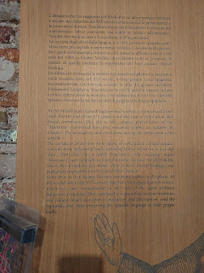

The tour began in the Campo (or Square) of the Jewish Ghetto, with a Jewish-Italian woman as our guide, who also happened to speak VERY good English. She asked us to look around and try to identify where the two synagogues were from where we stood. Nobody had a clue as to where they were. She explained that the Jews essentially had to protect the locations of their houses of worship, so they were hidden in plain sight. Notice the 5 upper windows in the photo below . . . this was a sign that here was a synagogue, the Scola Italiana. The 5 windows were symbolic of the 5 Books of the Torah, and also represented a spiritual resistance and devotion to their faith even under difficult conditions.

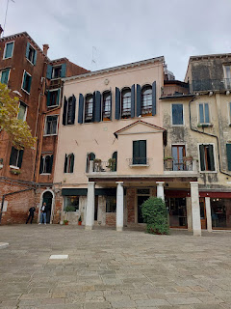

The entrance was downplayed and underrated, almost hidden on the left of David's Shop, a shop filled with various clothes and home goods. The Scola Italiana Synagogue was founded in 1575 by the Italian Jews. The interior is more modest compared to the other synagogues, both in size and decoration, but still elegant. The Italian Jewish community, which had a smaller population, preferred a simpler style of worship, reflected in the subsequent design of their synagogue.

The dark shape in the photo below is actually a "cupola" that sits above the "bimah", a small hint to observers down below that here is a synagogue. A bimah is a raised platform inside the synagogue with a reading desk where the Torah is read and other services are conducted. This second synagogue is known as Scola Canton. It was founded in 1531 by the Ashkenazi Jews (from Germany and Central Europe). We did not go inside this one.

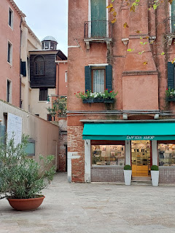

Before we toured the two upcoming synagogues, our guide gave us a little more history and background while we remained in the Campo (square). She told us that the Venetian Jews were not allowed to learn crafts or trades, because each craft or trade was associated with a Patron Saint and this was against their beliefs. Instead, they were allowed to learn only a handful of jobs, such as medicine, banking, and money lending.

Per AI info on the internet:

In the Venetian Ghetto, Jewish Banks were famously known by colors, like "Red Bank", "Green Bank", and "Black Bank", which refers to the color of the receipts issued to customers when they pawned items, essentially acting as pawnshops. The phrase "going into the red" is thought to originate from this practice of the "Red Bank", where borrowers received red receipts when taking out loans against pledged goods

.

There is a shop that still exists today in the Venetian Ghetto, called "Banco Rosa", effectively the "Red Bank".

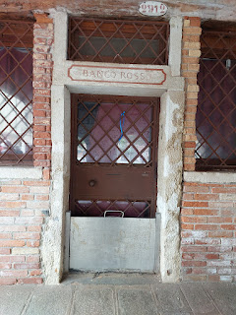

We went up several flights of stairs to get to the Italian Synagogue (Scola Italiana). It was very simple and modest, yet elegant.

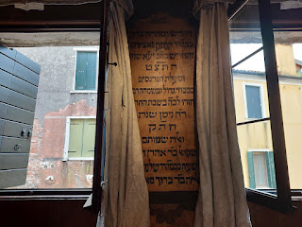

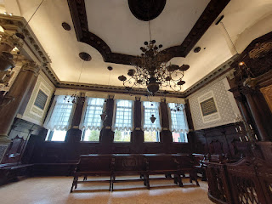

Below: This is the "Aron", inside the Italian Synagogue . . . it means "Holy Ark" in Hebrew. It is a cabinet that holds the Torah scrolls that are used for public worship. Typically, the Aron is directly across from the Bimah, and sits on the east wall facing Jerusalem.

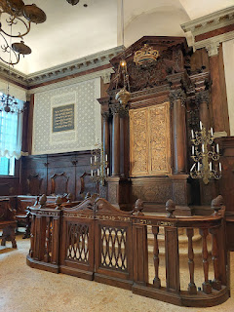

This is the Bimah, directly across from the Aron. In Hebrew, Bimah means "elevated place". Occasionally, the rabbi delivers his sermon from here, but mainly it's for the scriptures to be read from the Torah scrolls.

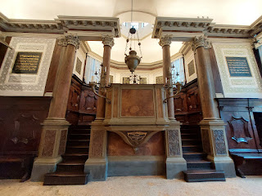

The Hebrew text in the frames hanging on the walls was difficult to translate, even with using Google Translate. I don't think it's a perfect translation, but here is what I got: "And you shall pray, but build above the Temple of the Cross, and build the city of justice, for the mercy of God, remove the dead end, every check, the crowd will celebrate, the king will rejoice in the stands, the king of Israel will ascend, and peace will abound in the city at the coming of the Messiah."

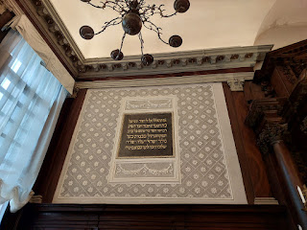

Another view of the Aron . . .

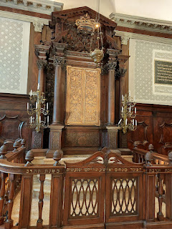

In the upper balcony, the curtains separate the chapel area from where the women can see and observe the reading of the Torah below. As I read about this custom on the internet, I came to realize that it has good intentions as its origin, but the logistics leave much to be desired. The idea behind the separation is so that men and women can focus more fully on their sacred experience if they are not distracted by each other. The logistical issues involved things relating mostly to comfort: upstairs and behind a curtain it is harder to hear the lecture, the temperatures often are sweltering, and the women often feel left out as a whole.

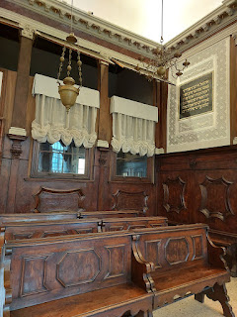

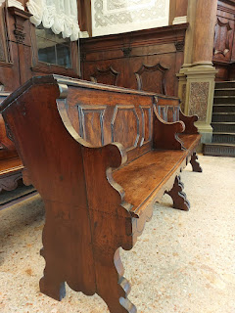

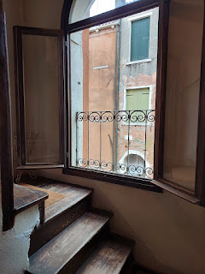

Heading back down to the unassuming entrance, I noted the very old exposed bricks and the well-worn flooring beneath my feet . . .

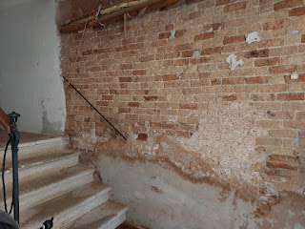

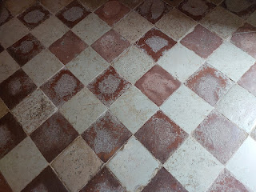

Our guide led us on a short walk through the Campo over to the Scola Levantina (Levantine Synagogue). We passed over the canal bridge where the second large gate was used to hold the Jews in the Ghetto at night.

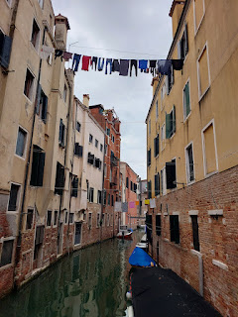

This is the entrance to the Scola Levantina . . .

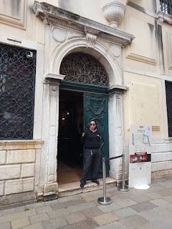

This synagogue was founded in the early 16th century by the Sephardic Jews from the Ottoman Empire. The Levantine community was wealthy, and their synagogue reflects their prosperity.

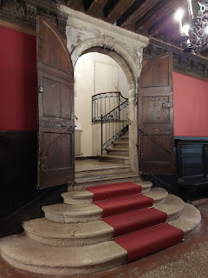

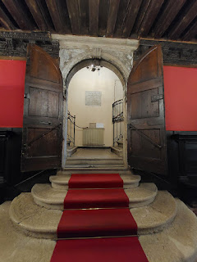

The woodwork was very dark and almost oppressive, but the red and white details brought a little bit of light into the room. Everything felt a lot more lavish here than in the Italian synagogue.

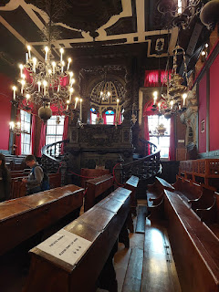

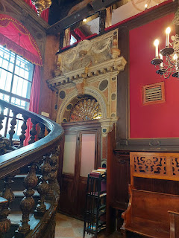

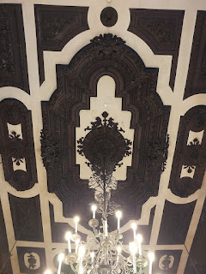

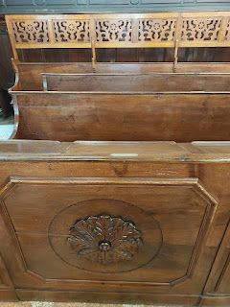

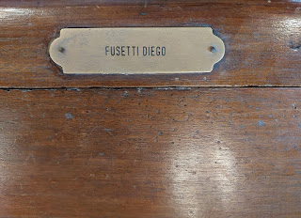

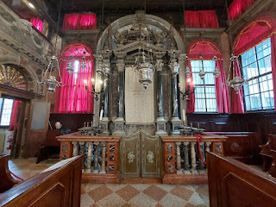

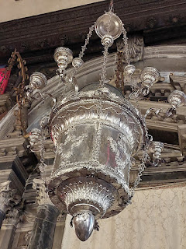

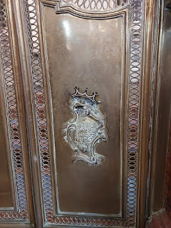

When using Google Translate, it can be a little hilarious at times. Take this next sign for example.

From Hebrew to English (the top half in the photo below): "A righteous person will run, sniff Jesus, from his front, the temple of God will look, pour out his speech, and you will slowly go out to keep his guest. The innocent flint will always be present."

From Italian to English (the bottom half): "Humble in action and with sincere faith here on the prayers may every pious man come to deposit. And whenever he turns his foot else, may he always keep his thought directed to God."

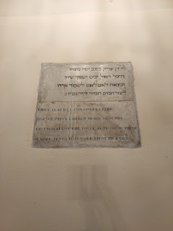

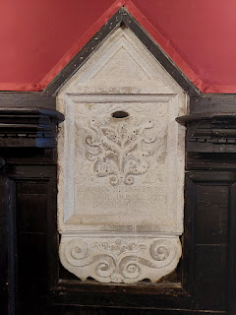

I didn't really feel anything special in either synagogue, to be honest. I don't know if it was because I was part of a tour and had to keep up, without much spare time to settle in and absorb the room. Or if it was because these two synagogues were not the ones that my ancestors attended. I have a feeling that they would have attended the Spanish Synagogue, which I have yet to visit. Their tours are scheduled on different days.

At the end of our tour, we were invited to visit the nearby "Secret Garden". It's not exactly secret anymore, because your synagogue tour ticket also allows you to enter this charming little garden, tucked away from most foot traffic. The entrance is through an old door that leads back to this . . .

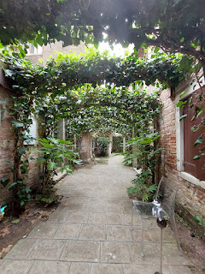

Per the internet:

"

The Secret Garden of the Scola Spagnola is a 110 square meter garden in Venice's Jewish Ghetto. It's located at the back of the Spanish Synagogue and features over 450 plants, trees, and essences from the Old Testament. The garden also includes a teaching area, a sukkah, and a fountain that symbolizes the River Jordan.

The garden reclaims a former orchard that stood for over 300 years. The orchard contained fig and pomegranate trees, vines for wine, and olive trees, all of which have deep symbolic meaning in Jewish tradition."

The fountain that symbolizes the River Jordan . . .

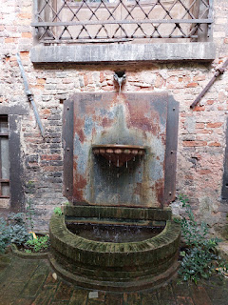

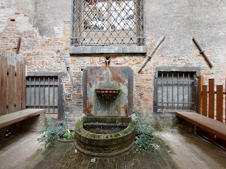

The Secret Garden was a delightful surprise and I thoroughly enjoyed wandering throughout the smallish space for a few minutes.

Video of the Garden: (13 seconds)

https://photos.app.goo.gl/ngZEpRkwSKGR26ck9

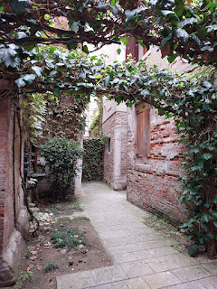

Time for a lunch break! I walked back over to the Ba'Ghetto Restaurant where Scott and I had eaten back in June. The first time here I chose the Jewish-style Cod and a Jerusalem artichoke, but this time I went with a completely different option: grilled chicken, salad, and fries. It was super tasty!

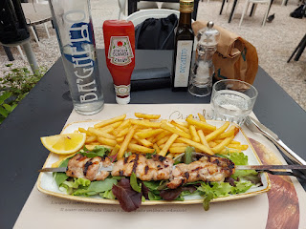

As I sat there eating my lunch, a lady at the table next to me began speaking to me - at first in Italian, ha ha, until she realized I couldn't quite keep up. Then she began cheerfully explaining to me in English how happy she was that there were some ripening pomegranates on the trees next to us (see photo below). That's when a second lady at another table a little further away overheard our conversation and started chiming in as well. They were talking about the significance of the pomegranate (particularly the seeds) with the upcoming Rosh Hashanah holiday (Jewish New Year). I didn't quite catch everything they were saying, but it had something to do with the number 613 and the number of seeds inside, and how this was somehow linked to the Old Testament.

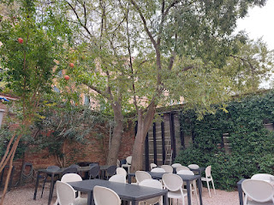

Using ChatGPT (my favorite AI app), this is what I later found:

"In Jewish tradition, the pomegranate holds deep symbolic significance, often representing righteousness, abundance, and divine favor. Its association with Jewish culture and religion is rooted in several key aspects:

1.

613 Seeds Symbolism:

According to tradition, a pomegranate is said to contain 613 seeds, symbolizing the 613 mitzvot (commandments) in the Torah. Although the exact number of seeds varies, this connection highlights the fruit's representation of fulfilling the commandments and living a righteous life.

2.

Biblical References:

The pomegranate is mentioned multiple times in the Hebrew Bible (Tanakh), often symbolizing fertility, prosperity, and beauty. For example, it is listed as one of the seven species that are special to the Land of Israel (Deuteronomy 8:8).

3.

High Holidays:

The pomegranate is commonly associated with Rosh Hashanah, the Jewish New Year. It is customary to eat pomegranates during the holiday, accompanied by a blessing asking that one's merits be as plentiful as the seeds of the pomegranate in the coming year.

4.

Temple Symbolism:

Pomegranates were also used as decorative motifs in the First and Second Temples. The tops of the pillars in Solomon's Temple were adorned with pomegranates (1 Kings 7:18-20), symbolizing beauty and divine presence.

These various meanings and uses contribute to the pomegranate's enduring significance in Jewish culture, symbolizing a connection between the physical and spiritual worlds."

I will never eat a pomegranate in the same way ever again . . . XO

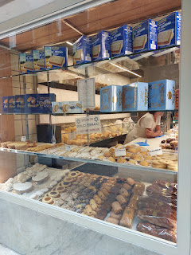

On my way to the train station, I was fascinated by the sweets in this kosher storefront window, so I went in and made a little selection. I purchased about 5-6 little dainty treats to share - not only with Scott, but with our friends who would be arriving the following day for a week-long visit.

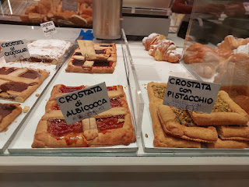

My favorite item was definitely the Crostata con Pistacchio. The Crostata di Albicocca was a close second. The other items were disappointingly dry and crumbly.

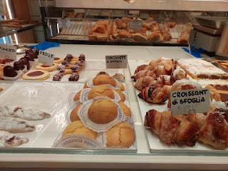

In typical Italian style, they packaged it all up beautifully for me to transport home on the train.

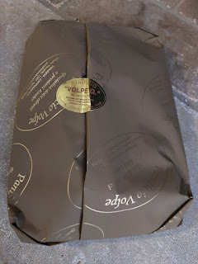

My two favorites were on the far left, while the rest didn't really get consumed. (Just a nibble)

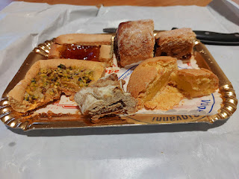

On the outskirts of the Jewish Ghetto, I walked past a few of the locals eating their lunch  . . . and they made my heart happy. I'm glad that these deeply religious people have more rights and freedoms today than what they've experienced in the past. Life is not perfect. Humans are not perfect. But as long as we are trying to do better than whatever we've done (or not done) in the past, we are on the right trajectory.

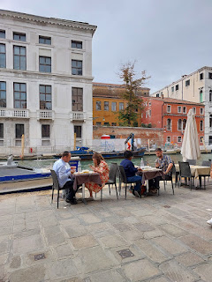

I am always drawn to this tree symbol whenever I see it here in Italy. It means so many things to me: my love for all the family members on my family tree, the Balsam Tree that is on the Bassano coat of arms, and the story and symbolism of the Tree of Life (in the Book of Mormon). When my artist daughter gets more settled into their new home in Portland, I hope she will paint me a tree like this . . .

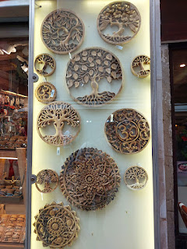

And that's a wrap. Gelato. Venice. Family. Finding. Learning. Experiencing. Becoming.

